Sprint 4 Plan
“Recommendation”

SlugIn

Aashna Shimkhada, Christina Chan, Erika Wu, Jetha Mot, Sara Srivastava, Sharon Akkara
Sprint Completion Date: November 18th, 2025
Revision 2: November 5th, 2025
Goal: To allow faculty and student leaders to post opportunities. To allow students to access and view these opportunities in a feed, save opportunities, and mark opportunities as applied.
Task listing, organized by user story:
User Story 1: (“As a student, I want to use the tags in the opportunities to filter, search, and find recommended opportunities by department or skill so I can discover relevant options efficiently.”) (26 points)
- Task 1.1: Set prefixed tags (department and majors) that will be listed as a dropdown menu in the “post opportunities” page (2 points)
- Task 1.2: Add a filter feature (12 points)
  - Task 1.2.1: Add “filter” button to opportunity page (1)
  - Task 1.2.2: Add “filter modal” that pop ups when filter button is clicked: (2)
    - Add a close button on the modal
  - Task 1.2.3: Add a text input boxes and appropriate descriptive text (2)
    - For department, skills, time commitment
  - Task 1.2.4: Add a “filter results” button (1)
  - Task 1.2.5: Save user input when “filter results” button is clicked (2)
  - Task 1.2.6: Add the logic such that only opportunities with the filtered categories appear (4)
    - Parsing through the opportunity schema (the category tags)
    - Allow loose spellings / capitalizations (Comp sci = computer science = Computer Science…)
    - Parsing through opportunity description (searching for time commitment, skills)
- Task 1.3: Add a search feature (5 points)
  - Task 1.3.1: Add text input box to opportunity page (1)
  - Task 1.3.2: Add search icon/button to the text input box (1)
  - Task 1.3.3: Implement on click, only show opportunities that mention user text input (3)
    - From any part of the opportunity schema (title, description, categories,...)
- Task 1.4: Add suggestion feature (19 points)
  - Task 1.4.1: Add a “Suggested Opportunities” button/toggle on the opportunities page (2)
  - Task 1.4.2: Add logic such that only opportunities the student has not marked as applied show up when button/toggle is on (3)
    - Reference the applications table in Supabase for applications linked to the student’s user ID
  - Task 1.4.3: Build on the previous logic to match that set of opportunities with the student’s interests (Major/Industry) (5)
    - Use the filtering logic to narrow down the scope of opportunities to ones related to their major/preferred industry from the student’s profile
  - Task 1.4.4: Rank these suggested posts so the earliest due date(but still not past the deadline) and relevant ones show up first (4)
    - Optional: Include a 1 sentence description of why the opportunity was suggested (ex: “suggested based on your major/industry”)
  - Task 1.4.5: If a student marks an opportunity as applied on the homepage (only for suggested opportunities), the opportunity card will disappear from the suggested posts (3)
    - Create an applied button on the opportunity cards for the student to click on for the opportunity to disappear.
  - Task 1.4.6: If no more relevant posts exist that the student has not already marked as applied, have text that says “No new suggested opportunities” on the home page (2)

User Story 2: (“As a faculty, I want to have all the relevant details of my opportunity (ex. deadlines, flyers, application link) included in the post so student can grasp a better understanding of it and I can manage it more efficiently”) (10 points)
- Task 2.1: Create a notification that the opportunity is about to expire ( 5 points)
  - Task 2.1.2: Add a badge that is located on my posts when the deadline ends in 2 days (2 points)
  - Task 2.1.2: Create an email notification that notifies the user that the deadline ends in 2 days (3 points)
- Task 2.2: Display more ways to include information about the opportunity in the post (5)
  - Task 2.2.1: Allow the user to add the image/flyer (3)
    - Task 2.2.1.1: Use the link to the flyer in the opportunities database to pull the flyer from Supabase storage and display in the post (2)
    - Tasks 2.2.1.2: If there is no link to a flyer, display a default image (1)
  - Task 2.2.2: Add an “apply now” button in the “Opportunities” page that directs the user to the application (2)
    - Task 2.2.2.1: Require the link to apply when creating a post in the “Post opportunities” page, so button directs to that link

User Story 3: (“As a student and faculty, I want to be able to view only the appropriate features and pages according to my role”) (12 points)
- Task 3.1: Add a role to user depending on if they used student or club/faculty sign up (3)
  - Task 3.1.1: Add a “role” field to the “profiles” table in Supabase (1)
  - Task 3.1.2: When inserting a new row into the “profiles” table on account creation, add “student” if user used student sign up or “faculty” if user used club/faculty sign up (2)
- Task 3.2: Remove access to “Post opportunities” page on both the navigation bar and URL for students using the Supabase database (4)
- Task 3.3: Allow faculty users to open edit modal on their opportunities on the "Opportunities” page (3)
- Task 3.4: Allow users to view the opportunities on the "Opportunities” page in three columns to remove the white space on the sides (2)

User Story 4.4 (Bonus story) - using AI API to help recommend opportunities?
Team roles:
Aashna Shimkhada - Developer
Christina Chan - Product Owner, Developer
Erika Wu - Scrum Master
Jetha Mot - Developer
Sara Srivastava - Developer
Sharon Akkara - Developer

Initial task assignment:
Aashna Shimkhada - US 2 Task 2.1, US 1 Task 1.2
Christina Chan - US 2 Task 2.2, US 3 Task 3.4
Erika Wu - US 1 Task 1.1, US 3 Task 3.1 & 3.2
Jetha Mot - US 1 Task 1.2
Sara Srivastava - US 1 Task 1.4
Sharon Akkara - US 1 Task 1.3, US 3 Task 3.1 & 3.3

Initial burnup chart: A graph giving the initial burnup chart for this sprint and is labeled as such with sprint number and project name and is located in the lab. 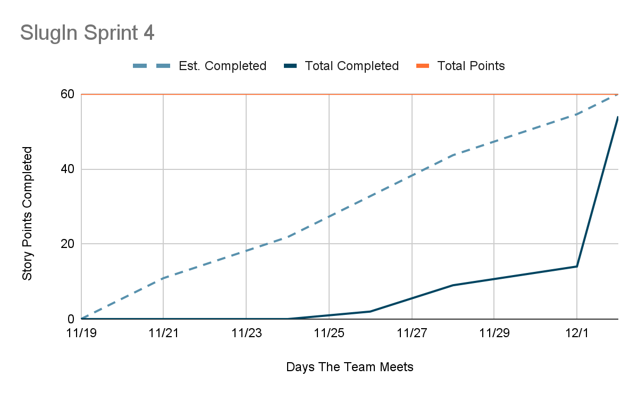

Initial scrum board: Also known as a task board, the scrum board is a physical board and labeled as such with sprint number and project name and located in the lab. This board has four columns, titled user stories, tasks not started, tasks in progress, and tasks completed. Index cards or post-it notes representing the user stories and the tasks for this sprint should be placed in the user stories, tasks not started, and tasks in progress columns. Tasks associated with a user story should be placed in the same row as the user story.

User story | Task | In progress | Complete | Story points
User Story 1 | 1.1 | X - Erika 11/22 | X - Erika 11/28 | 2
 | 2 | X - Jetha 11/24 | X - Jetha 12/2 | 12
 | 3 | X - Sharon 11/24 |  | 5
 | 4 | X - Sara 11/30  X - Erika 12/2 | X - Sara & Erika 12/2 | 19
User Story 2 | 1 | X - Aashna 11/22 | X - Aashna 11/28 | 5
 | 2 | X - Christina 11/24 | X - Christina 11/30 | 5
User Story 3 | 1 | X - Aashna 12/2 | X - Aashna 12/2 | 3
 | 2 | X - Aashna 12/2 | X - Aashna 12/2 | 4
 | 3 |  |  | 3
 | 4 | X - Christina  11/26/25 | X - Christina 11/26/25 | 2

Scrum times: List at least the three days and times during the week when your team will meet and conduct Scrum meetings. Also, indicate which of these meetings will have the TA/tutor visit as arranged with the TA/tutor. It is expected the TA/tutor will visit during the Scrum meeting during your lab time.

Times meeting:
- Friday 1:30 pm -2 pm
- Wednesday 1:30 pm - 2 pm
- Monday 1:30 pm - 2 pm
Meeting with TA:
- Wednesday 4:30 pm - 5:15 pm

